10.1.1 Remove Punctuations From a string
Algorithm
1.Start
2.Input the string
Read a string from the user and store it in a variable X.
3.Initialize a new string
Create an empty string Y = "" to store the result after removing punctuation.
4.Traverse the string
Take each character i from the string X one by one using a loop.
5.Check character type
For each character i, check:
6.If it is a letter (A–Z or a–z)
OR a digit (0–9)
OR a space
7.Condition check
If the character satisfies the above condition , then:
Append the character i to string Y
Otherwise ignore it
8.Repeat the process
Continue steps 4–6 until all characters of the string X are processed.
9.Display the result
Print the final string Y which contains no punctuation marks.
10.Stop
Flowchart
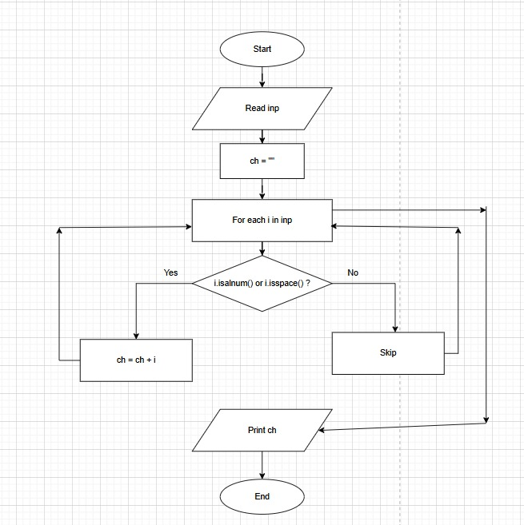
PYTHON CODE
inp = input()
ch = ""
for i in inp:
if i.isalnum() or i.isspace():
ch = ch+i

print(ch)

EXCECUTION
